**DAILY ONLINE ACTIVITIES SUMMARY**

|  |  |  |  |  |  |  |  |
| --- | --- | --- | --- | --- | --- | --- | --- |
| **Date:** | **07/06/2020** | | | | **Name:** | **ROHAN VASHISTA BM** | |
| **Sem & Sec** | **6th Sem & B** | | | | **USN:** | **4AL17CS078** | |
| **Online Test Summary** | | | | | | | |
| **Subject** | | **SSCD test-3** | | | | | |
| **Max. Marks** | | **30** | | **Score** | | **24** | |
| **Certification Course Summary** | | | | | | | |
| **Course** | **Full stack development** | | | | | | |
| **Certificate Provider** | | | **Udemy** | **Duration** | | | **19.5 hrs** |
| **Coding Challenges** | | | | | | | |
|  | | | | | | | |
| **Status: completed** | | | | | | | |
| **Uploaded the report in Github** | | | | **yes** | | | |
| **If yes Repository name** | | | | <https://github.com/Rohanvasista/Coding-activities> | | | |
| **Uploaded the report in slack** | | | | **yes** | | | |

**Online test details**

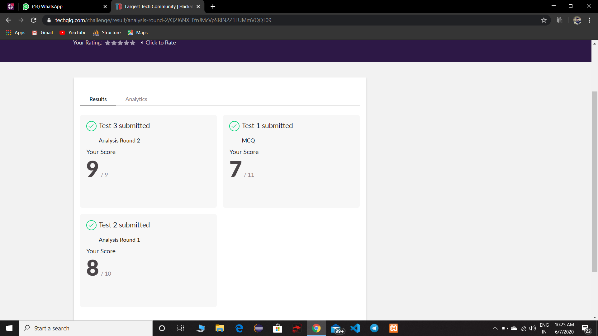

**Certification Details**

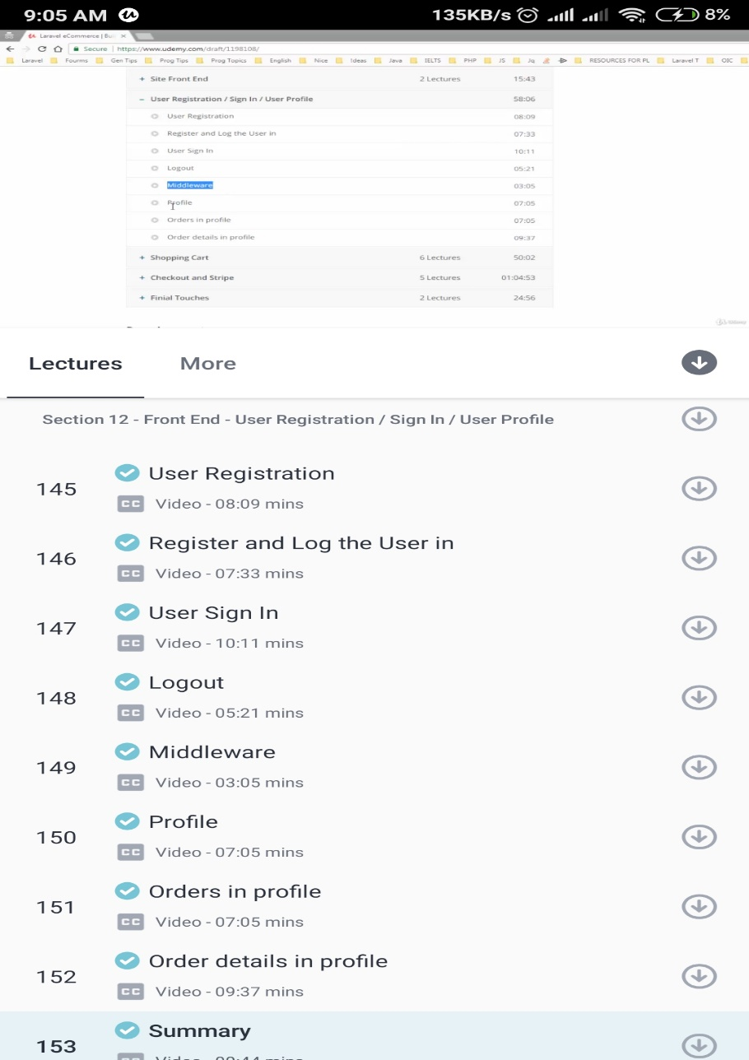

* Today I have studied about front end work like user registration ,log-in ,user sign-in, logout and middleware’s concept .

**Coding Challenge Details**

1. **Python program to count number of strings**

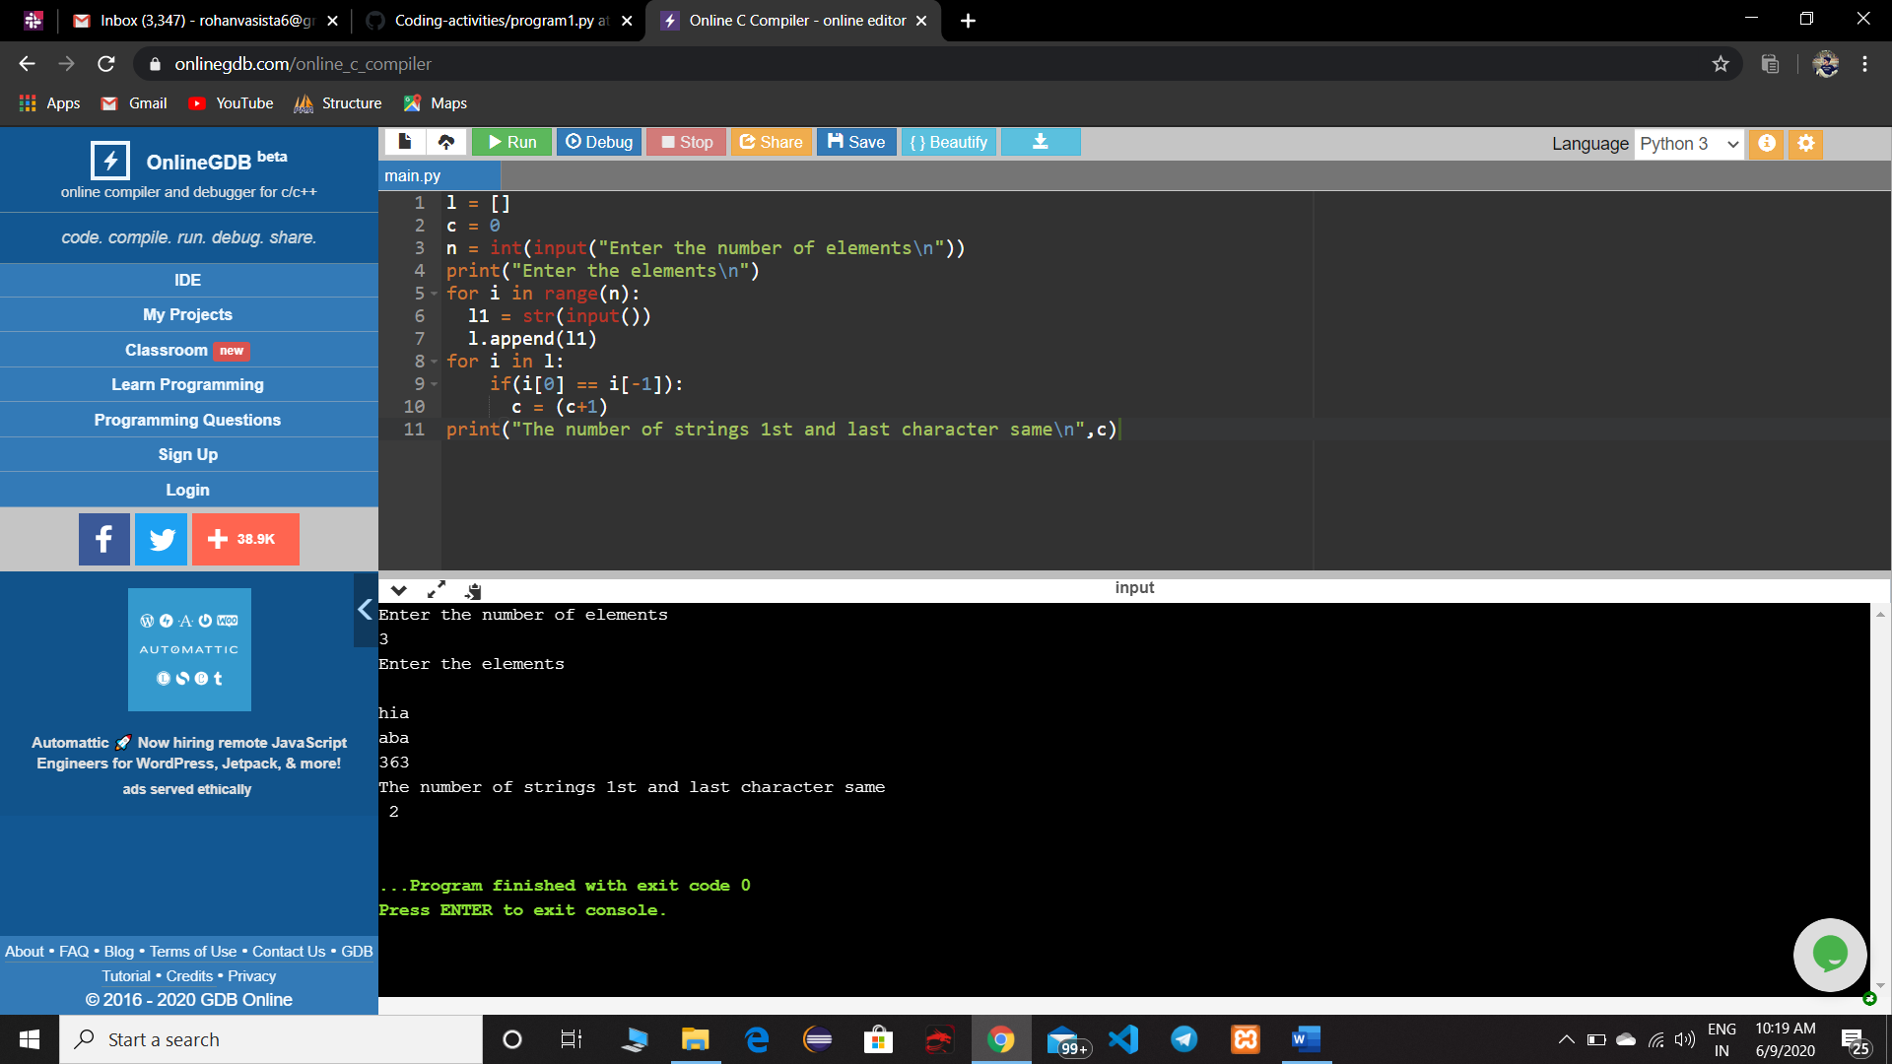

|  |
| --- |
|  |
|  |
|  |

1. **Python program to square each odd number in the list**

